**Web Development**

**Re-Engineering of Preston Website**



**Aqal Noor**

**Reg.No. 2121-315044**

**Khawar Ali**

**Reg.No. 2121-315054**

**Saif Mansoor**

**Reg.No. 2121-315006**

**Rovaid Yousaf**

**Reg.No. 2121-315024**

**Preston University Kohat**

**Department of Computer Science**

**Re-Engineering of Preston Website**

**Web Development**

**Re-Engineering of Preston Website**



**Aqal Noor**

**Reg.No. 2121-315044**

**Khawar Ali**

**Reg.No. 2121-315054**

**Saif Mansoor**

**Reg.No. 2121-315006**

**Rovaid Yousaf**

**Reg.No. 2121-315024**

**Preston University Kohat**

**Department of Computer Science**

**Dedication**

*This report is dedicated to our beloved parents.*

**Approval Sheet**

Project Name**:** ………………………………………………………….

Organization Name**:** …………………………………………………...

Group Members**:** ………………………………………………………...

Supervisor Name**:** ………………………………………………………..

Position**:** ………………………………………………………………….

Date: Project Supervisor

_____________ _____________

**Preface**

Our project is to Re-engineering Preston University website. The reason we chose this project, after examining the weakness of Official Preston University website. The weaknesses are that it is not responsive (screen size adjusted with all devices), not include features such as learning management system. Our purpose to make this website responsive. We took this project because it is our subject requirement and to improve the web programming skill. This project is assigned by our teacher (Mr. Awais Qureshi) in order to implement what we learn theoretically. We have done this project in time period of two months. We got a good experience about web project.

**v**

**vi**

**Acknowledgements**

First of all, we would like to thanks Almighty Allah to give us strength and knowledge. Second, we would like to thank our project’s supervisor (Mr. Awais Qureshi) to give us opportunity to prove ourselves in practical work. Our thanks and appreciation also go to Ms Sania Zaheer Ali in developing project’s report.

**viii**

**Executive Summary**

This purpose of this report was to explain our project based on Preston University website. Research for this report included a review of web development.

The major findings indicate that while there is a need for some caution, responsive website should be seen as a way of increasing the number of visitors and learning management system currently being offered in universities.

It is divided on three chapters, introduction, web development, and design and analysis. The introduction section includes background, purpose, objectives, and significance of the study, and research methodology.

Second section is about web development, its technologies, and its programming languages and type of web developers. Final section is around design and analysis phase. The design represents the whole look of the website and analysis represents website strong and weak points.

While it is clear that student needs will vary, this report recommends that Preston University website must be responsive and implement online approach for Learning Management System.**Table of Contents**

**vii**

**iv**

**Chapter 1 Introduction**

Background of the Study………………………………………………….. 1

Purpose of the Study………………………………………………………. 1

Objective of the Study…………………………………………………….. 2

Significance of the Study………………………………………………….. 2

Research Methodology……………………………………………………. 3

* Primary Resources………………………………………………… 3
* Secondary Resources……………………………………………… 3

Scheme of the Study………………………………………………………. 3

**Chapter 2 Web Development**

Introduction………………………………………………………….…… 4

Types of Website……………………………………………….………… 4

* Static …………………………………………………………….. 4
* Dynamic………………………………………………………….. 5

Technology Based of Web Development

* Browser……………………………………….…………………. 5
* Framework…………………………………….………………… 5
* Library…………………………………………………………… 5

**viii**

**Table of Contents**

Languages Based of Web Development………………………………… 5

* HTML……………………………………….…………………. 5
* CSS………………………………………..…………………… 5
* JavaScript………………………………..…………………….. 5
* PHP………………………………….…………………………. 6

Front-End Developer………………………….………………………. 6

Back-End Developer……………………….………………………….. 6

**Chapter 3 Design and Analysis**

Cover Image…………………………….…………………………….. 7

Menu……………………………………………………………………… 8

Responsive Windows……………………………………………………... 9

Learning Management System……………………………………………. 10

Online Admission…………………………………………………………. 10

Online Result……………………………………………………………… 11

Contact……………………………………………………………………. 11

Analysis………………………………………………………………….. 12

* Strength…………………………………………………………… 12
* Weakness………………………………………………………….. 12

**ix**

**CHAPTER ONE**

**Introduction**

**Overview**

This chapter consists of the following sections; background, purpose, objectives and significance of the study and research methodology.

* 1. **Background of Study**

We aimed to develop a standardized website and overcome the limitations of the present website. The new site has responsive window, menus and other web contents. The word responsive means the contents of the website are adjusted with respect to screen size.

The main reason behind developing this site was that the Preston University website is not responsive that the contents are not adjusted with some devices like tablets, mobiles, and having no such service that user can check assignment and internal marks, etc. The other reason is our course demanded to implement what we learned, and to gain experience in this field.

We chose Preston University organization website that there are many issues in it, like the website is not responsive, old style menus and lack of different services.

* 1. **Purpose of Study**

The purposes of the study can be enumerated as follows.

1. To become capable of practically implementing what we were learning theoretically in the subject of web development.
2. Compulsory part of our course.

**1**

1. To gain experience in web development field
2. Be able to join *Fiverr* website(an Online marketplace)
3. To become able a part of any software house or business organization as web developer or web designer.
   1. **Objectives of Study**

The objectives of the study are as follows:

1. To make the site compatible with laptops, tablets and mobiles.
2. To give a smart look (standard).
3. Add new services and features.
4. To enable the Search Engine Optimization (display on first page at top in Google).
5. Increase the speed of response time.

**1.4 Significance of Study**

The website has new extra services such as LMS (Learning Management System) and online admission for students. The new website is not only responsive for laptops but also compatible for tablets and mobiles. We gave a new look to Preston University Official website with animated menus and advance designs.

Moreover, the significance of this website is that, it helps us to practical practice and experience web development and to make background portfolio. This website is also a source of motivation for us for undertaking future web based projects.

**2**

**1.5 Research Methodology**

**1.5.1 Primary Resource**

We got web based programming basics and procedure from subject lecturer, which tools and languages are to be used and how to use them. HTML, CSS, JavaScript, Bootstrap and IDE (Sublime Text 2) were our sources of primary data.

**1.5.2 Secondary Resource**

We most visited a website *www.w3schools.com* which has a lot of information of web development and watched many tutorials videos about web designing.

**1.6 Scheme of the Study:**

**Chapter One Introduction**

This chapter consists of the following sections; background, purpose, objectives and significance of the study and research methodology.

**Chapter Two Web Development**

This chapter includes information about web development, web programming languages, and technologies that are used in web development field.

**Chapter Three Design and Analysis**

This chapter includes over all presentation of website (cover image, menu, responsive window, Learning Management System, online admission, contact) and analysis.

**3**

**CHAPTER TWO**

**WEB DEVELOPMENT**

**Overview**

This chapter includes information about web development, web programming languages, and technologies that are used in web development field.

**2.1 Introduction**

Web development is a vast field of computer science. In web development, developers create, design and maintain websites. A website is a collection of webpage. A website may create using web programming languages such as HTML, CSS, JavaScript, and PHP. There are two basic of websites like static (web contents are fixed to everyone) and dynamic (Website contents are change for different events). There are three types of developer (programming) front-end (developer whose work on HTML, CSS, and JavaScript), back-end (developer whose work on PHP, ASP), and full stack (both front-end and back-end).

**2.2 Types of Websites**

There are two main types of website i.e. static and dynamic websites.

**2.2.1 Static**

Static websites are those websites that its contents are fixed and display the similar information to every user. Static websites are generally created by HTML. Static websites are easy to develop and host. It takes short span of time for creating such type of websites.

**4**

**2.2.2 Dynamic**

Dynamic websites are defined as that its contents may change form different user.

These types of website contain web pages that are generated in real time .These websites are based on scripting languages JavaScript, PHP, ASP etc.

**2.3 Technologies Based on Web Development**

**2.3.1 Browser**

A browser is software that is used to access internet and web pages. e.g. Google Chrome, Opera etc.

**2.3.2 Framework**

Framework is platform of any language. It has predefined classes which make programmer work easier. e.g. bootstrap.

**2.3.3 Libraries**

Library is the collection of the specific classes which are used for specific purpose.

Example: jquery is the library of JavaScript.

**2.4 Languages Based on Web Development**

**2.4.1 HTML** (Hyper Text Markup Language) is used to create a webpage.

**2.4.2 CSS** (Cascading Style Sheet) is used for give a layout and style. It is used for designing WebPages.

**2.4.3 JavaScript** is used to change the behavior of the website contents

**5**

**2.4.4 PHP** is used to manage dynamic content, databases, session tracking. It is mostly used for e-commerce websites.

**2.5 Front-End Developer**

The front end of a website is that part which is visible to the user. Front-End developer means those programmers which work on HTML, CSS and java script languages to develop a web site.

In Front-End developer create whole website including menu, navigation bar, forms, landing page etc.

**2.6 Back-End Developer**

Back-end is the part of website where the website’s data are stored, retrieved and edited. Back-End developer is defined as the developer whose is responsible to create and maintain entire back-end of systems which consist of application and databases. The back-end developers generally work on dynamics type of websites. Those developers are always working with PHP and ASP.

**6**

**CHAPTER THREE**

**DESIGN AND ANALYSIS**

**Overview**

This chapter includes over all presentation of website (cover image, menu, responsive window, Learning Management System, online admission, contact) and analysis.

**3.1 Cover Image**

Cover image is the main image of the website. Website usually represented by cover image. It gives fist impression to the visitors. It reflects the whole picture of the website. At the right-top, three bars shaped menu trigger button is placed.

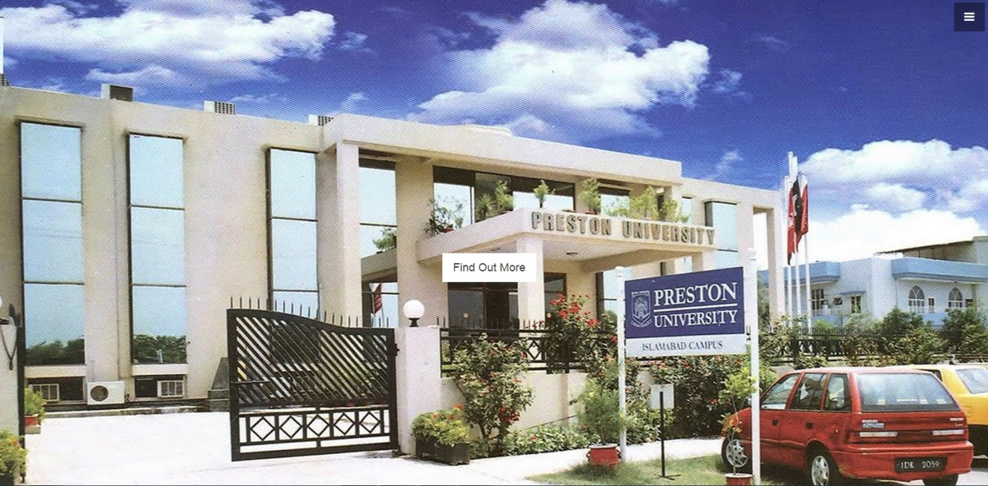

**7**

**3.2 Menu**

Menu is a list of options of different categories. Menu contains main sections of the website.

Menu is an alternative way to access the website contents. It is easy to manage one section instead of all sections in one. It reduces complexity.

We developed this menu by JavaScript language. When user clicks of three-bar icon, menu will appear at the right side of the window. The three-bar icon fixed at right-top when user scroll the window. The menu contains home, about, programs, campuses, admission, alumni, result, LMS, login sections. If user clicks on any section, the page will be scroll up to content of that section. If user does want to click on any section, then user just click of cross icon.

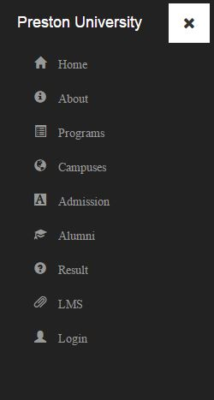

**8**

**3.3 Responsive Windows**

Responsive is a term that the content of the website compatible for every type of devices such as laptops, tablets, mobiles. In responsive website, the menu, content every data adjusted with respect to its screen size.

Many organization websites are not responsive, that’s why different device user (mobiles and tablets) face difficulties.

We developed a responsive website through Bootstrap framework. Bootstrap divides screen into rows and columns with respect to its screen size. Nowadays the trend is that a website must be responsive.

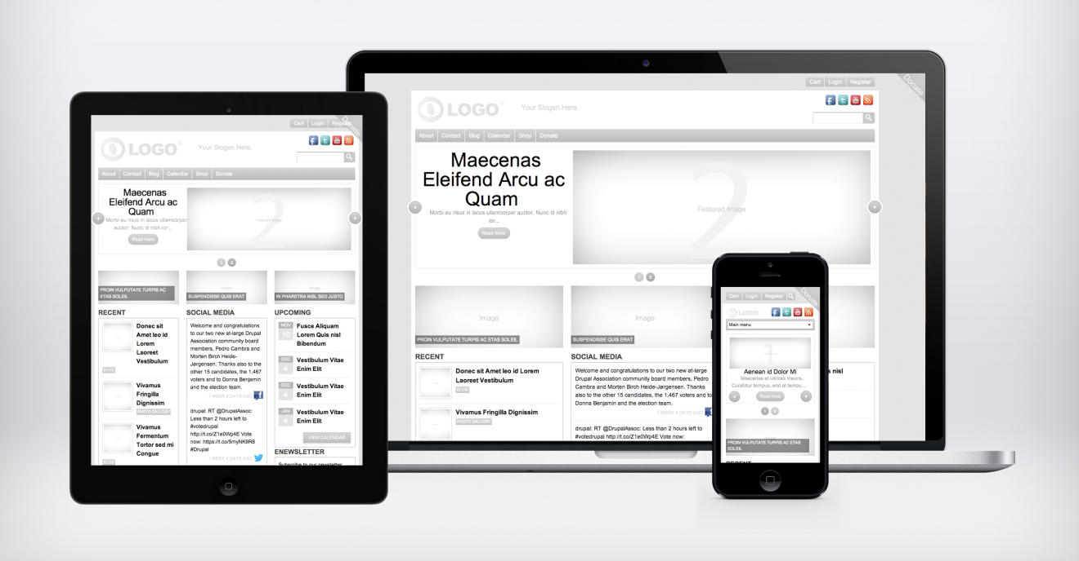

**9**

**3.4 Learning Management System**

Learning Management System provides facility to check online marks of mid-term and internal. LMS is a feature which should be included in educational website.

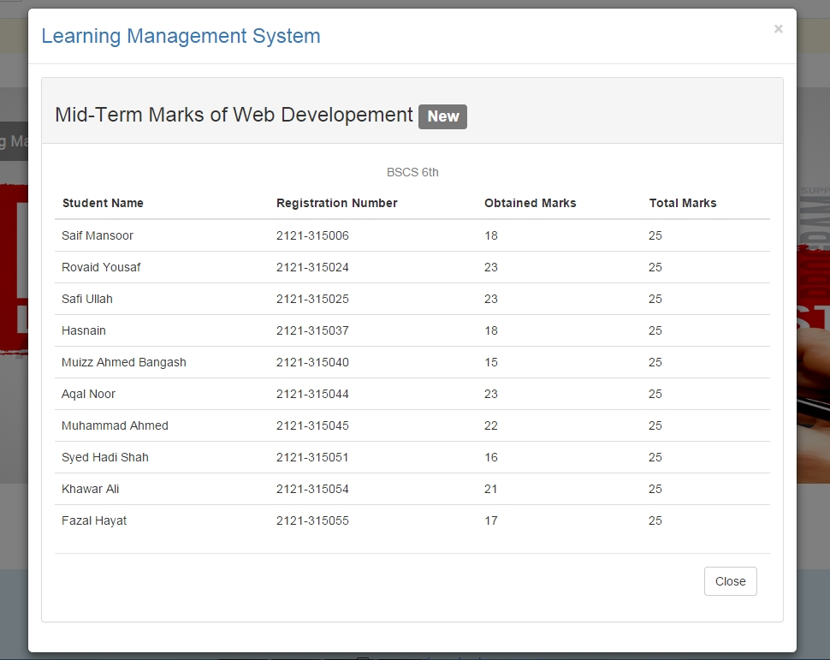

**3.5 Online Admission**

Every organization wants to give facilities as much as they can; online admission is very important features in it. If user lives out of city, he can easily get online admission.

**10**

**3.6 Online Result**

Students can get result or DMC online through this website. User selects his semester type, year, exam type and enter registration number and then click on Search button.

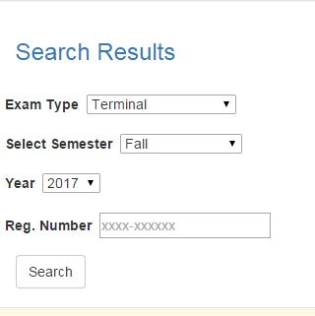

**3.7 Contact**

If user has any problem or query and want to give a feedback, so he or she can easily content through email or telephone number. User can easily get updates about events and information. User can get access to Home page through the bottom at bottom-right side.



**11**

**3.8 Analysis**

**3.8.1 Strength**

The strengths of the website are enumerated as follows:

1. Responsive design.
2. Stay updated.
3. Relevant contents.
4. No broken links.

**3.8.2 Weakness**

The weaknesses of the website are as follows:

1. Outdated data.
2. Lack of privacy
3. No advisement place
4. Lack of data.

**12**